Q1) **Design a flowchart, Pseudocode, Algorithm for processing a customer order at a restaurant, including handling special requests (Like add on).**

Ans1)

Start

Output “Hello sir/madam what will u have today?”

Output menu

Read order

If customer wants add ons

Then Output “What would u like to add onto that sir”

Else

Output “is that all”

EndIF

Input the order into the machine

Process the amount

Output “Your total will be”, amount

Input Cash

If Cash == amount

Then Output recipet and Display “Please wait for your order”

Else if Cash > amount

Then Output Remaining money and Display “There is your money”

Else

Display “the cash you paid is less than the amount”

Repeat step 13

End if

End

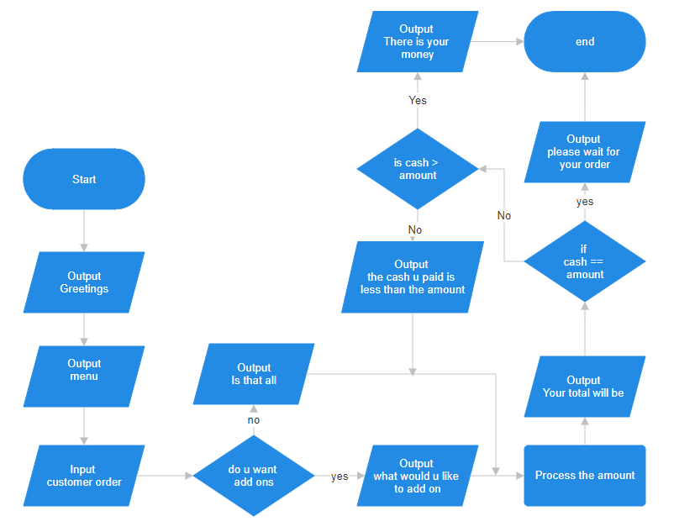

Q2) **Design a flowchart, Pseudocode, Algorithm for handling a customer's deposit transaction at a bank, including checks for account validity and deposit amount conditions.**

Ans2)

Start

Output "Please enter your card number."

Read card_number.

If card_number exists in the bank's system:

Output "Please enter your PIN."

Read PIN.

If PIN is correct:

Output "Please select the amount of money you would like to deposit."

Read deposit_amount.

If deposit_amount > deposit_limit:

Output "The amount you are depositing exceeds the limit; please decrease the amount."

Else:

Output "The amount has been deposited into your account."

Output "Your new balance is: " + new_balance.

End If

Else:

Output "Invalid PIN. Please try again."

End If

Else:

Output "Sorry, the card number you entered is invalid. Please try again."

Repeat step 2

End If

End

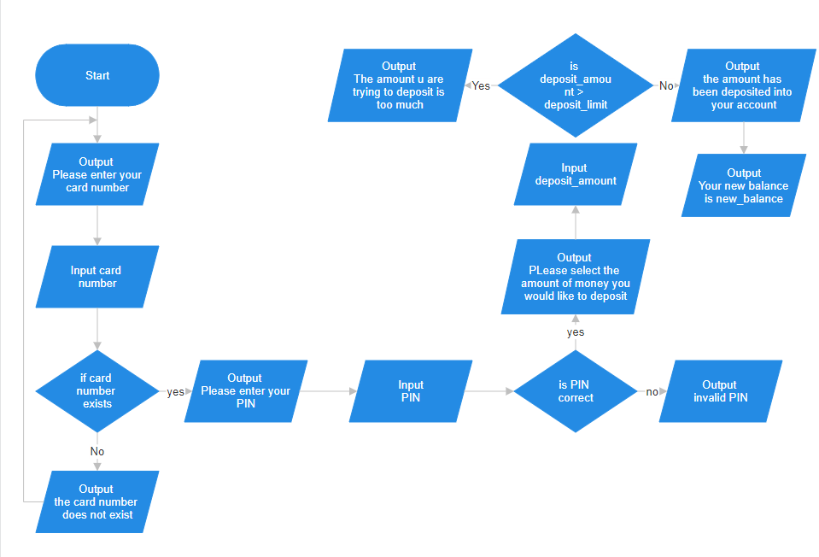

Q3)**Design a flowchart, Pseudocode, Algorithm to determine which of three provided numbers is the greatest.**

Ans3)

Start

Output “please enter three different number”

Read x, y, z

If x>y

Then if x>z

Output “x is the greatest number”

Else

Output “z is the greatest number”

End if

Else

If y>z

Then Output “y is the greatest number”

Else

Then Output “z is the greatest number”

End if

End

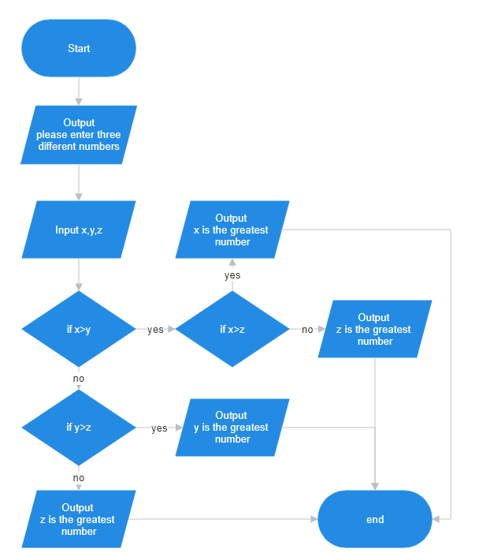

Q4)**Implement an algorithm where the user enters a number, and an appropriate month is displayed.**

Start

Output “Please enter a number between 1 and 12 to display the corresponding month.”  
read num

If num = 1

Then Output “The month is January”

Else If num = 2

Then Output “The month is febaury”

Else If num = 3

Then Output “The month is march”

Else If num = 4

Then Output “The month is april”

Else If num = 5

Then Output “The month is may”

Else If num = 6

Then Output “The month is june”

Else If num = 7

Then Output “The month is july”

Else If num = 8

Then Output “The month is august”

Else If num = 9

Then Output “The month is spetember”

Else If num = 10

Then Output “The month is ocotober”

Else If num = 11

Then Output “The month is November”

Else If num = 12

Then Output “The month is December”

End

Q5) **Create pseudocode a small calculator which only does ‘+’ or ‘-‘Operations. (Hint: Take three variable inputs with one being used for the operator)**

Ans5)

Start

Output “please enter the first number)

Read num1

Output “please enter the second number”

Read num2

Output :please enter the operator You want to use on the two numbers(+or-)”

Read Op

If Op == “+”

Then Calculate sum = num1 +num2

Else

Calculate sum = num1 – num2

Output sum

End

Q6) **You are working at Toyota Indus Motors and want to assemble a car. Design a flowchart with proper process modules and decision structures to replicate a pipeline production.**

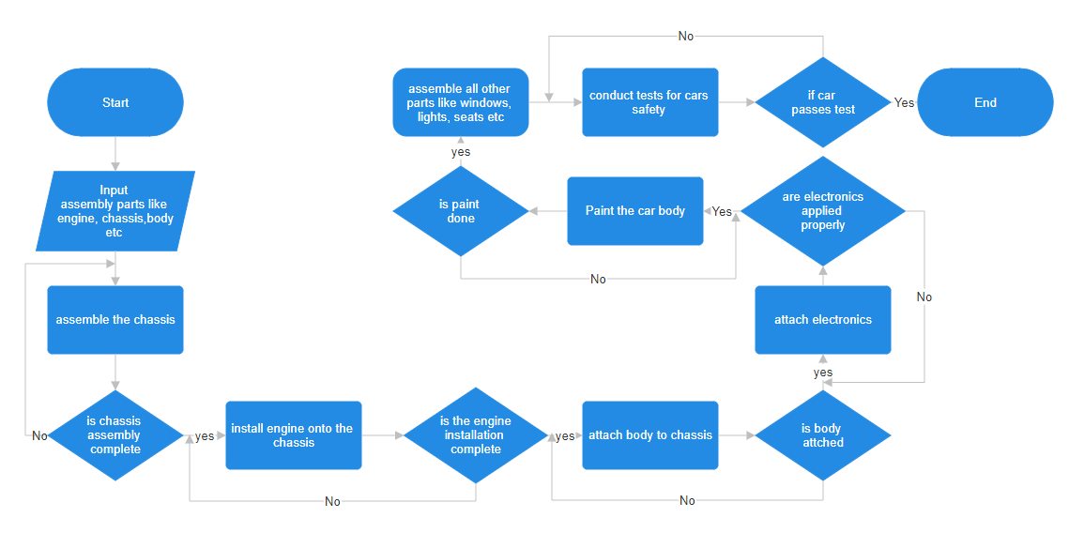

Q7) **Implement an algorithm for making a simple calculator with all the operators (+,-,*,/,%)**

Ans7)

Start

Output “please enter the first number”

Read num1

Output “please enter the second number”

Read num2

Output “please enter the operator You want to use on the two numbers(+or-)”

Read Op

If Op == “+”

Then result = num1 + num2

Else if Op == ”-“

Then result = num1 – num2

Else if Op == “*”

Then result = num1 * num2

Else if Op == “/”

Then result = num1 / num2

Else

Output “please enter a valid operator which can be either +, -, * or /”

End if

End

Q9)**Why we use .gitignore**

Ans9)The purpose of gitignore files is to ensure that certain files not tracked by Git remain untracked

Q10) **Difference between Algorithm and Pseudocode?**

An algorithm is a finite set of instructions that, if followed, accomplishes a particular task.

Which are clean and unambiguous, finite and efficient.

While Pseudocode is a way to express an algorithm or program logic in a human-readable form.it is the most simplest form of code